TRENDS ANALYSIS OF USED-CAR PRICES OVER THE YEARS

**Analysis Insight**

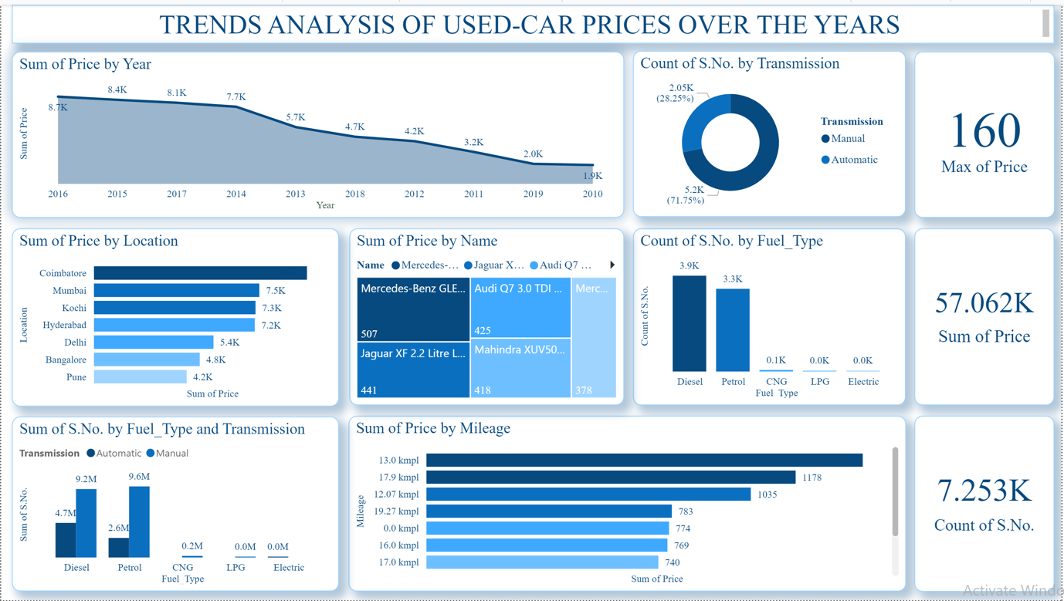

**Observations:**

**1. Trend Analysis of Used-Car Prices Over the Years**

The sum of prices for used cars has generally declined over time. The highest total price was observed in 2016 at **8.7K**, with a consistent decrease, reaching **1.0K** in 2010.

This decline could indicate either a reduction in the resale value of cars over time or changes in the volume of transactions.

**2. Sum of Price by Location**

Coimbatore has the highest total price of used cars (**7.5K**), followed closely by Mumbai (**7.5K**) and Kochi (**7.3K**).

Pune has the lowest total price (**4.2K**) among the listed locations.

Regional factors, such as demand, supply, or cost of living, might influence these variations.

**3. Transmission Type Distribution**

The majority of cars have automatic transmission (71.75%), with **5.2K** entries.

Manual transmission cars account for **28.25%** (**2.05K**).

This suggests a strong preference for automatic cars in the dataset.

**4. Sum of Price by Name**

The **Mercedes-Benz GLE Class** has the highest total price (**507**).

Other high-value models include the **Audi Q7 3.0 TDI** (**425**) and the **Jaguar XF 2.2 Litre Luxury** (**441**).

Premium and luxury brands dominate the high-price category.

**5. Fuel Type Analysis**

Diesel cars are the most common, with a count of **3.9K**, followed by petrol cars at **3.3K**.

CNG, LPG, and electric cars are negligible in the dataset, suggesting a limited presence of alternative fuel vehicles.

**6. Transmission and Fuel Type Combination**

Diesel cars with manual transmission lead the count (**9.6M**), followed by petrol cars with automatic transmission (**9.2M**).

Cars with alternative fuels like CNG, LPG, and electric show minimal representation across both transmission types.

This indicates a dominance of conventional fuel types across transmission categories.

**7. Price vs. Mileage**

Cars with a mileage of **13.0 kmpl** have the highest total price (**1,178**), followed by those with **17.9 kmpl** (**1,035**).

Mileage between **12.07 kmpl** and **19.27 kmpl** shows a consistent demand for moderately fuel-efficient cars.

**Metrics**

**Maximum Price:**

The highest price recorded in the dataset is **160**.

**Total Price of All Cars:**

The sum of prices across all cars is **57.062K**.

**Total Count of Cars (S.No.):**

There are **7.253K** cars in the dataset.

**Key Insights**

Used car prices have declined over the years, potentially reflecting depreciation trends or market saturation.

Diesel cars dominate the market, indicating a preference for fuel-efficient, high-torque vehicles.

Automatic transmission cars are significantly more popular, suggesting a shift toward convenience.

Premium car models from brands like Mercedes, Audi, and Jaguar lead in terms of price, indicating a demand for luxury in the used car market.

Geographic differences, as seen in the location-wise analysis, suggest varying market dynamics that may depend on regional economic factors.

**Recommendations:**

**1. Pricing Strategies**

**For Dealers:**

Focus on selling cars in high-demand locations such as **Coimbatore, Mumbai, and Kochi**, where the total price of cars is higher. Consider regional price optimizations to capitalize on higher willingness to pay.

Introduce competitive pricing strategies in lower-price locations like **Pune** to attract more buyers and increase sales volume.

**For Buyers:**

Explore markets like **Pune** and **Bangalore** to find relatively lower-priced cars compared to cities like Coimbatore or Mumbai.

**2. Inventory Management**

**Transmission:**

With **71.75%** of the dataset showing a preference for automatic transmission, dealers should maintain a higher inventory of automatic cars to meet market demand.

While manual cars are less common, there is still a market for them, especially for cost-sensitive buyers or niche markets.

**Fuel Type:**

Diesel cars dominate the dataset, indicating strong demand. Dealers should stock more diesel models, especially for high-mileage users or regions where diesel fuel is cheaper.

Petrol cars are also significant, and a balanced inventory of petrol and diesel cars will cater to diverse customer needs.

Promote alternative fuel vehicles (CNG, LPG, electric) in cities where environmental consciousness and government incentives for green vehicles are growing.

**3. Marketing and Promotions**

**Luxury Brands:**

High-value brands like **Mercedes-Benz**, **Audi**, and **Jaguar** have a significant presence. Focus marketing efforts on premium customers through luxury-focused campaigns.

Highlight features like engine power, brand prestige, and resale value to attract buyers for high-end models.

**Mileage Efficiency:**

Cars with mileage in the range of **13-19 kmpl** are most common and have higher prices, indicating customer preference for fuel-efficient models.

Dealers should advertise these mileage brackets as a key selling point for fuel-conscious buyers.

**4. Regional Insights**

**Coimbatore, Mumbai, and Kochi:**

These locations have higher aggregate prices, suggesting strong demand or premium car sales. Tailor marketing campaigns to target affluent buyers in these regions.

**Lower Demand Regions (Pune):**

Implement aggressive discounts or trade-in offers to boost sales. Explore partnerships with local mechanics and finance providers to enhance accessibility.

**5. Fuel Type and Green Initiatives**

Promote awareness and adoption of **electric, CNG, and LPG cars** as they are currently underrepresented. Work with manufacturers and policymakers to offer incentives like reduced taxes, subsidies, or zero-interest financing for eco-friendly vehicles.

**6. Customer Segmentation**

**First-Time Owners:**

Focus on selling diesel and automatic cars to cater to first-time buyers looking for convenience and reliability.

Provide maintenance packages to ensure retention of these customers for servicing needs.

**Cost-Sensitive Customers:**

Offer manual transmission cars and older models with reasonable prices in markets like Pune or Bangalore.

**High-End Buyers:**

Promote premium cars and emphasize value retention, mileage, and brand recognition.

**7. Sales Planning**

**Model-Specific Insights:**

Focus on promoting high-priced models such as the **Mercedes-Benz GLE Class** and **Audi Q7 3.0 TDI**. These cars can generate more revenue per sale.

**Depreciation Awareness:**

Use the declining price trend over the years to educate buyers about value depreciation and encourage them to invest in newer used cars (e.g., cars from 2015-2016 with a higher price base).

**8. Expand the Alternate Fuel Market**

Create partnerships with energy providers to build the infrastructure for **electric and CNG vehicles**, especially in high-demand urban areas.

Target environmentally conscious buyers by promoting hybrid and electric cars with incentives and showcasing long-term savings.

**9. After-Sales Services**

Offer tailored service plans for **diesel and automatic cars**, given their dominance in the market.

Provide warranty options for premium car models to reassure high-end customers about reliability.

**10. Digital Experience Enhancements**

Use data-driven dashboards like this one to create interactive online platforms for buyers.

Allow customers to filter cars by **mileage, fuel type, transmission, and price range** to personalize the buying experience.

**11. Policy Recommendations for Stakeholders**

**For Government Agencies:**

Encourage the adoption of green vehicles through policies, such as reduced road tax for electric vehicles or subsidies for CNG and LPG adoption.

Implement region-specific policies to manage demand, such as incentivizing low-income buyers in lower-demand areas like Pune.

**For Manufacturers:**

Focus on producing more automatic cars and fuel-efficient models to meet evolving consumer preferences.

**Conclusion**

The insights derived from this dashboard indicate a market heavily influenced by location, transmission type, fuel efficiency, and brand preferences. By leveraging these recommendations, stakeholders can align their strategies to increase revenue, improve market share, and cater to evolving consumer demands.